Simons Baked Egg Pan
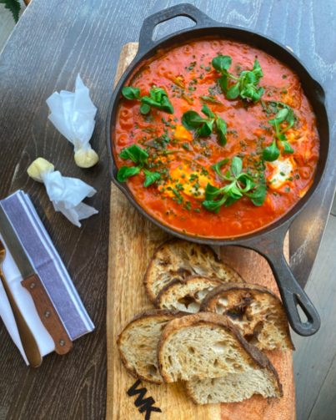
Ingredients
- 50g spinach
- 2 whole pieces of chorizo – cut in half lengthways and then again
- 250g potato
- 75g cooked onions
- Arribiatta Sauce (Recipe Below)
- 4 eggs
- 2 slices sourdough
- Garnish:
- 5g chives
- 10g lambs lettuce
Simons Arrabbiata Sauce
Ingredients
- 2 Shallots finely diced
- 2 gloves Garlic crushed into a paste
- 2 Red Chilli’s finely chopped
- ½ Teaspoon Dried Red Chilli
- 70g Fresh Basil Chopped
- 1 Tablespoon olive Oil
- 1 Litre passata
- 1 Tin chopped tomato
- 1 tablespoon tomato puree
- 10 ripe cherry tomatoes quartered
- 2 teaspoons fresh oregano
- 2.5 tsp. Smoked Paprika
- Sea Salt and Black pepper

Simons Arrabbiata Sauce
Method
In a large saucepan Gently Heat your olive oil and then add in your garlic paste, stir gently for around 20 seconds, next add in your shallots and soften gently for a couple of minutes.
Once your shallots are softened add in your oregano, and chilli, cook this out for another minute, then add in your tomato puree and smoked paprika and cook for another minute stirring frequently, next go in with your quartered cherry tomatoes, and then add your passata and your tin of chopped tomatoes and cook the sauce gently for 30 minutes, stir in your chopped basil and cook for another 20 seconds season, taste and then serve.

Egg Pan Method
- Add all ingredients to a cast iron pan or oven proof dish
- Add in 100ml water, Stir and season, place lid on pan
- Once liquid starts to bubble crack 4 eggs into it
- Cook for 3-4 minutes, remove and garnish with chives and lambs lettuce
- Serve with Toasted Bread

