Simons Arrabbiata Sauce

The perfect addition to any form of Pasta and let’s face it there’s always some in the cupboard

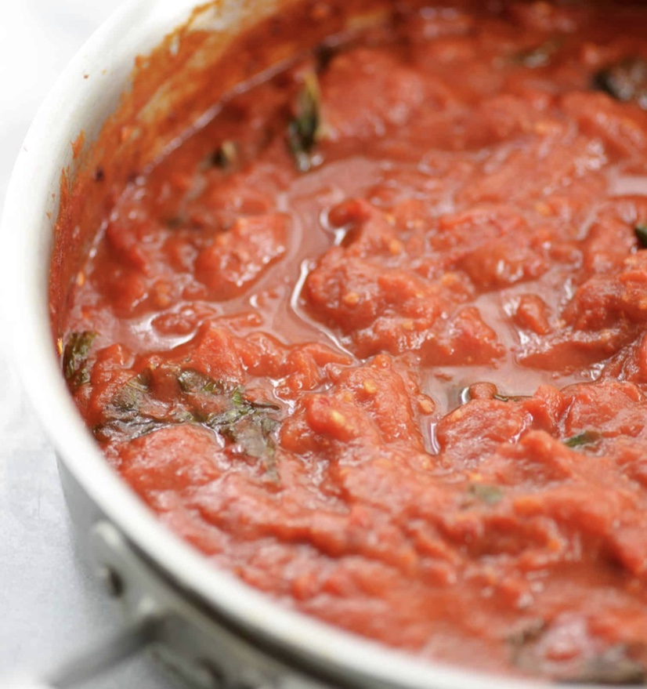

Ingredients

- 2 Shallots finely diced
- 2 gloves Garlic crushed into a paste
- 2 Red Chilli’s finely chopped
- ½ Teaspoon Dried Red Chilli
- 70g Fresh Basil Chopped
- 1 Tablespoon olive Oil
- 1 Litre passata
- 1 Tin chopped tomato
- 1 tablespoon tomato puree
- 10 ripe cherry tomatoes quartered
- 2 teaspoons fresh oregano
- 2.5 tsp. Smoked Paprika
- Sea Salt and Black pepper

Method

In a large saucepan Gently Heat your olive oil and then add in your garlic paste, stir gently for around 20 seconds, next add in your shallots and soften gently for a couple of minutes.

Once your shallots are softened add in your oregano, and chilli, cook this out for another minute, then add in your tomato puree and smoked paprika and cook for another minute stirring frequently, next go in with your quartered cherry tomatoes, and then add your passata and your tin of chopped tomatoes and cook the sauce gently for 30 minutes, stir in your chopped basil and cook for another 20 seconds season, taste and then serve.

Manchester Massive Mac Sauce Recipe

Simons At Home Store Cupboard Manchester Massive Mac Sauce

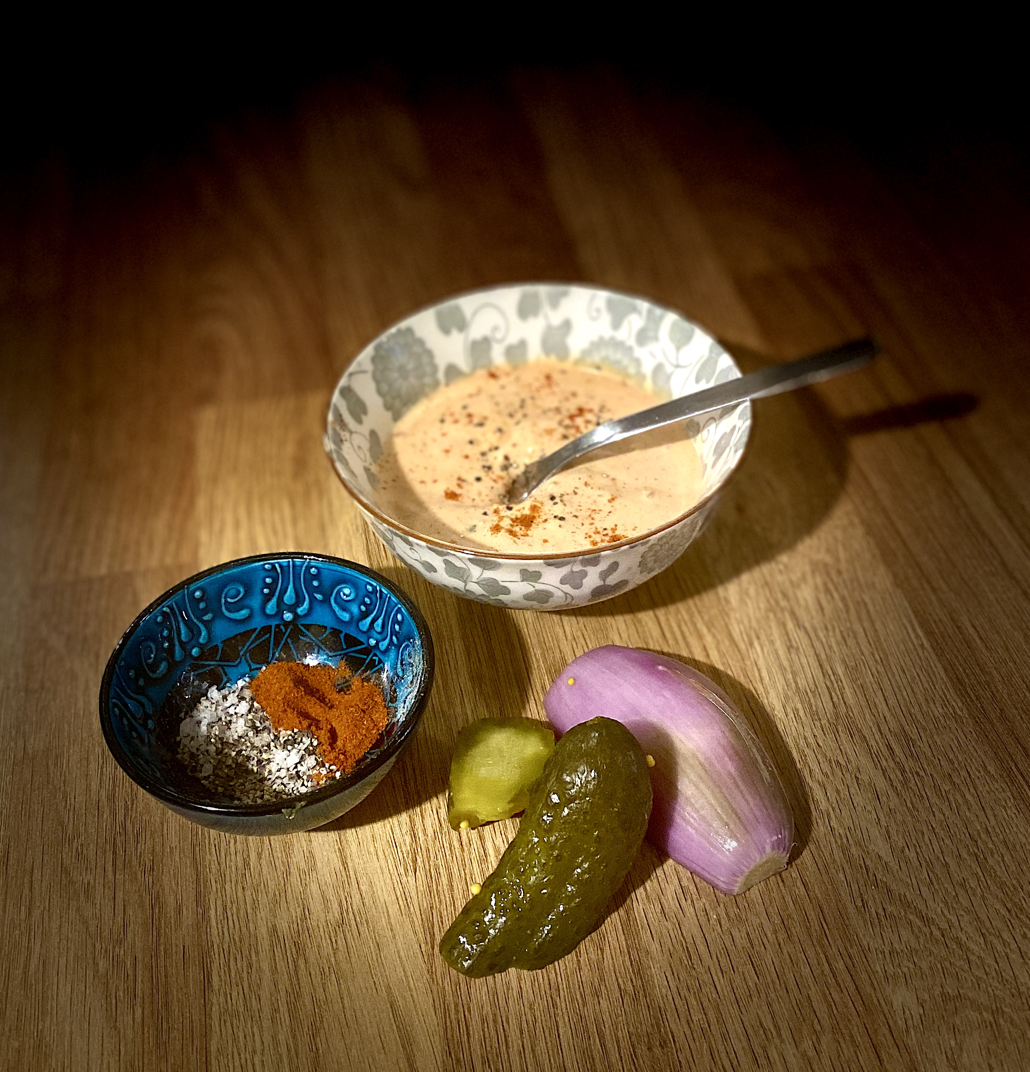

- 200g Ketchup
- 200g Mayonnaise
- 30g Dijon Mustard
- 1 Teaspoon Paprika (Optional if you have it)
- ½ Teaspoon Onion Powder (Optional if you have it)
- 1 Shallot Finely Diced
- 1 Gherkin Finely Diced
- Black Pepper
- Sea Salt

Method

Add all the ingredients to a bowl and mix well!

Video Attached

Mushroom Risotto

There’s rice in the cupboard put it to good use…... a tasty veggie treat that will feed the whole family…. Twice, easily.

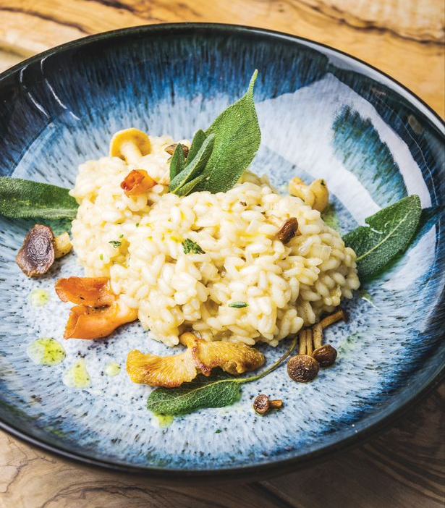

Ingredients

- 1 vegetable stock cube
- 2 tbsp olive oil
- 1 onion, finely chopped
- 2 garlic cloves, grated
- 250g pack of any mushrooms, chopped
- 300g risotto rice, such as arborio (but use what you have available)
- 2 x 175ml glass white wine (One for you, One for the pan)
- 25g butter
- handful parsley leaves, chopped or 12 teaspoons of dried
- 50g Veggie parmesan or Grana Padano, freshly grated (if you have it)

Method

Crumble 1 vegetable stock cube 700ml boiling water.

Heat 2 tbsp olive oil in a shallow saucepan or deep frying pan over a medium heat. Add 1 finely chopped onion and 2 minced garlic cloves, then fry until soft.

Stir in 250g chopped mushrooms, season with salt and pepper and continue to cook for 8 mins until the fresh mushrooms have softened.

Add your butter and then Tip 300g rice into the pan and cook for 1 min. Pour over a 175ml glass of white wine and let it bubble to nothing so the alcohol evaporates. At this point you can enjoy your glass of wine, I’m partial to a Gavi di Gavi

Keep the pan over a medium heat and pour in a quarter of the vegetable stock. Simmer the rice, stirring often, until the rice has absorbed all the liquid.

Add about the same amount of stock again and continue to simmer and stir - it should start to become creamy, plump and tender. By the time the final quarter of stock is added, the rice should be almost cooked.

Continue stirring until the rice is cooked. If the rice is still undercooked, add a splash of water.

Take the pan off the heat, and scatter over 25g grated parmesan or Grana Padano cheese and half a handful of chopped parsley leaves.

Cover and leave for a few mins so that the rice can take up any excess liquid as it cools a bit. Give the risotto a final stir, spoon into bowls and scatter with the remaining 25g grated cheese and the remaining chopped parsley leaves.

Citrus Tutti-Frutti – The MasterChefUK Final Dessert

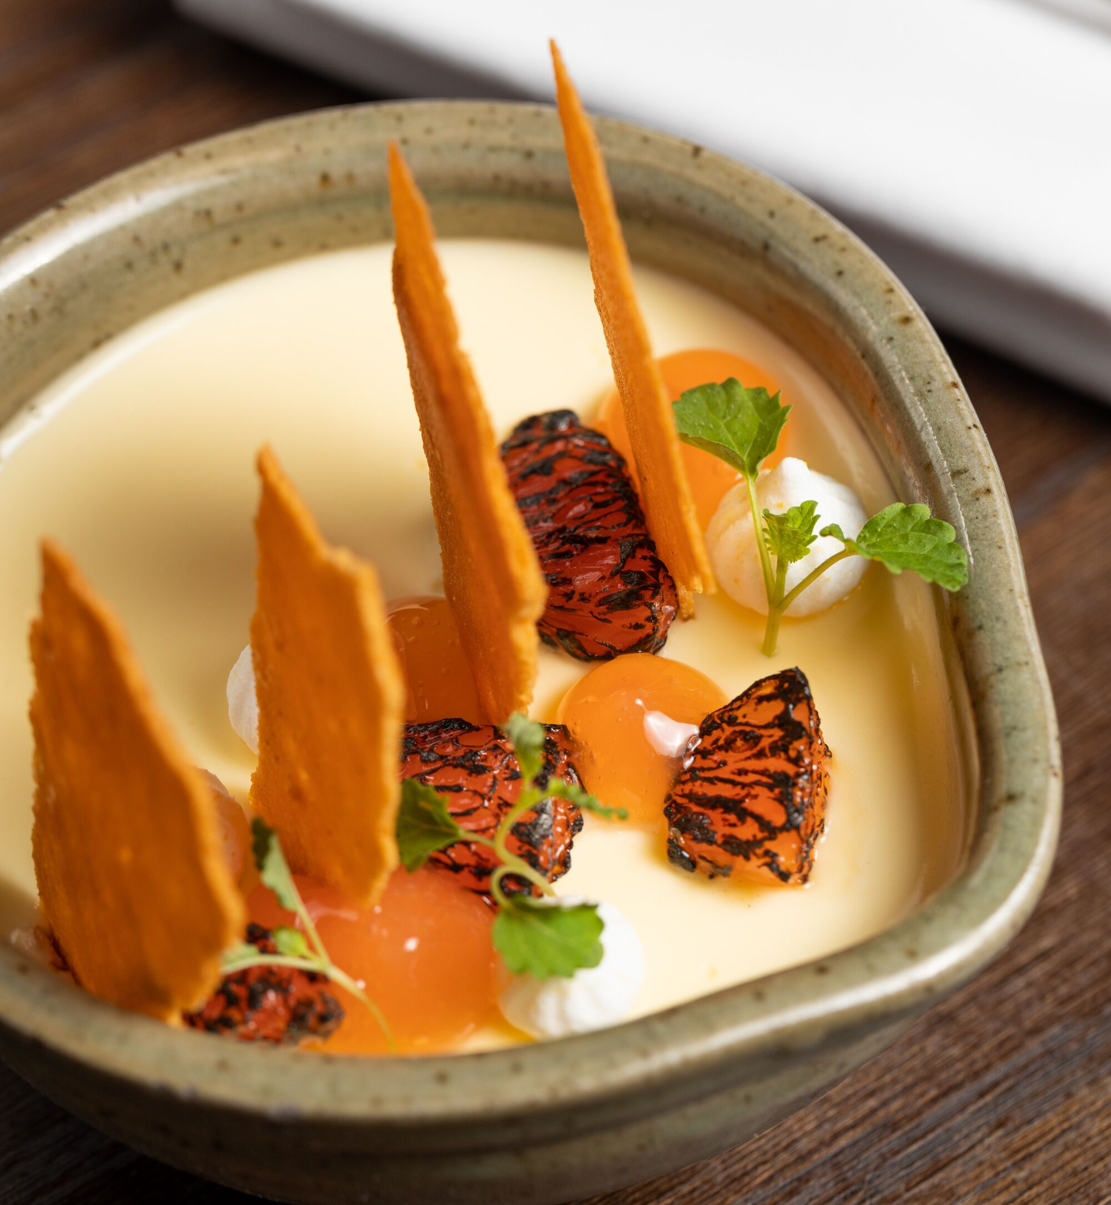
Ingredients
- 300ml double cream
100g golden caster sugar
1 lemon & 1 Lime Zest and juice
1 pink grapefruit, segmented

Method

Heat the cream and sugar for 3 minutes, add juice of the lemon & lime and combine together until just starting to boil

Pour into serving glasses and chill in the fridge for 3 hours.

Segment the pink grapefruit and char with a blowtorch. If you don’t have a blowtorch you can place the segments under a hot grill but do watch them you just want to char them.

