Poutine
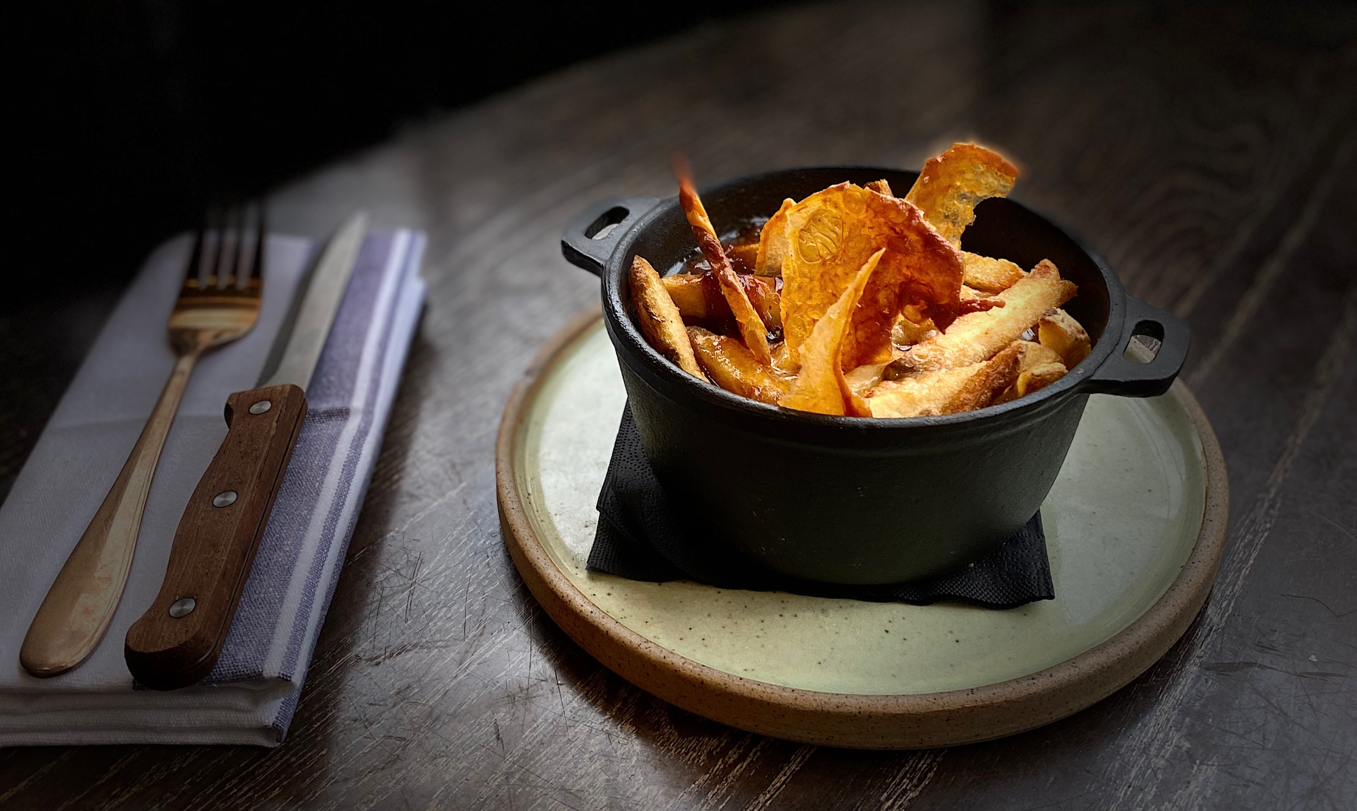
Ingredients
- 150g chips
- 100g ready-made gravy
- 100g cheese curds
- 100g crispy chicken skin
Chicken skin
- Place skin between two baking trays, season well and cook for 25 mins at 200 degrees, until golden
Method
- Place your cooked chips in large cast iron dish layering the cheese curds as you go. Place in oven for 8 mins
- Pour in gravy and top with broken pieces of crispy skin

Poutine is a dish that includes French- fries and cheese curds topped with a brown gravy.
It originated in the Canadian province of Quebec and emerged in the late 1950s in the Centre-du-Québec area.
It has long been associated with Quebec cuisine. For many years, it was perceived negatively and mocked, and even used by some to stigmatize Quebec society.
Poutine later became celebrated as a symbol of Québécoiscultural pride. Its rise in prominence led to its popularity outside the province, especially in Ontario, the Maritimes, and in the North-eastern United States. And more recently @WOODKRAFTCheltenham

