Simons Simple Pesto

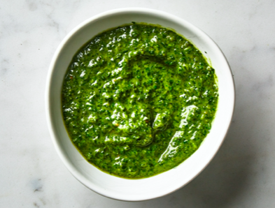

Ingredients
- 50g pine nuts
- 2 garlic cloves
- Two large bunches of basil
- 50g Parmesan
- 150ml olive oil
- Juice of half a lemon
Method

In a large frying pan toast your pine nuts until golden
Next use the back of your knife to crush your garlic into a smooth paste, a little sea salt will help to do this.

I make my pesto in a food processor, but you can use a pestle and mortar, Toast your Nuts in a frying pan and then with the exception of the lemon juice add in all the remaining ingredients and blitz into a smooth paste, taste and add the lemon juice and adjust the seasoning accordingly.

This will go amazingly well with Pasta, meat or roasted vegetables

